Contents

1. Introduction 2
2. Problem Statement 2
3. Objectives of the Project 3
4. Scope of the Project 3
5. Tools and Technologies Used 3
7. SQL Implementation 4
8. Output 8
9. Learning Outcomes 8
10. Conclusion 9

Cablytics: Data-Driven Ride Analysis Platform

Introduction

In the modern digital world, data analytics plays a crucial role in decision-making across industries. The transportation and ride-hailing sector generates a vast amount of data every day, including ride timings, locations, fares, and distances. Analyzing this data helps companies understand customer behavior, optimize operations, and improve overall efficiency.
The project “Cablytics: Data-Driven Ride Analysis Platform” focuses on analyzing ride data using SQL and visualizing insights using Microsoft Excel. This project demonstrates how raw data can be processed, analyzed, and transformed into meaningful insights.
The primary goal of this project is to identify patterns such as peak ride hours, popular pickup and drop locations, fare distribution, and total revenue generation. These insights can help businesses make informed decisions.

Problem Statement
Transportation companies often struggle to:
- Identify peak demand hours
- Understand customer travel patterns
- Optimize pricing strategies
- Analyze revenue effectively
Without proper data analysis, decision-making becomes inefficient and inaccurate.
This project aims to solve these problems by:
- Structuring ride data
- Performing SQL-based analysis
- Visualizing results using Excel

Objectives of the Project
The key objectives of this project are:
- To design a structured database for ride data
- To perform data analysis using SQL queries
- To extract meaningful insights from ride data
- To create calculated fields such as hour and day
- To visualize data using charts and graphs
- To build a dashboard for better understanding
- To improve decision-making using data insight.

Scope of the Project
This project focuses on:
- Small-scale ride data analysis
- Basic SQL operations (SELECT, GROUP BY, COUNT, AVG, SUM)
- Data visualization using Microsoft Excel
- Dashboard creation
The project can be extended in the future to include:
- Real-time data processing
- Machine learning models
- Large-scale datasets

Tools and Technologies Used
Tool | Description
MySQL | Used for database creation and querying
SQL | Used for data analysis
Microsoft Excel | Used for data visualization
Dataset | Manually created ride data

- Database Design
Column Name | Data Type | Description
ride_id | INT | Unique ride identifier
pickup_datetime | DATETIME | Date and time of ride
pickup_location | VARCHAR | Starting location
drop_location | VARCHAR | Destination
fare_amount | DECIMAL | Cost of ride
distance | DECIMAL | Distance traveled
duration | INT | Time duration

SQL Implementation
- Database and Table Creation

CREATE DATABASE ridepulse;
USE ridepulse;

CREATE TABLE rides (
ride_id INT PRIMARY KEY,
pickup_datetime DATETIME,
pickup_location VARCHAR(50),
drop_location VARCHAR(50),
fare_amount DECIMAL(10,2),
distance DECIMAL(5,2),
duration INT
);

- Data Insertion
INSERT INTO rides VALUES
(1, '2024-01-01 08:30:00', 'Downtown', 'Airport', 250.00, 10.5, 25),
(2, '2024-01-01 09:00:00', 'Mall', 'Station', 120.00, 5.0, 15),
(3, '2024-01-01 18:45:00', 'Office', 'Home', 200.00, 8.0, 20),
(4, '2024-01-02 20:00:00', 'Airport', 'Hotel', 300.00, 12.0, 30),
(5, '2024-01-02 22:15:00', 'Downtown', 'Mall', 150.00, 6.0, 18),
(6, '2024-01-03 07:45:00', 'Home', 'Office', 180.00, 7.5, 22),
(7, '2024-01-03 19:30:00', 'Mall', 'Home', 160.00, 6.5, 19),
(8, '2024-01-04 23:00:00', 'Station', 'Downtown', 220.00, 9.0, 24);

- SQL Queries Used
- Hour-wise Ride Analysis
SELECT HOUR(pickup_datetime) AS hour, COUNT(*) AS total_rides
FROM rides
GROUP BY hour
ORDER BY total_rides DESC;
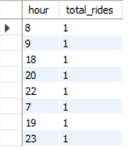

- Pickup Location Analysis
SELECT pickup_location, COUNT(*) AS total_rides
FROM rides
GROUP BY pickup_location
ORDER BY total_rides DESC;
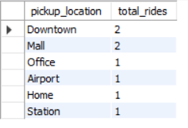

- Drop Location Analysis
SELECT drop_location, COUNT(*) AS total_rides
FROM rides
GROUP BY drop_location
ORDER BY total_rides DESC;
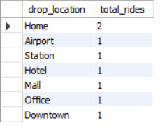

- Average Fare
SELECT AVG(fare_amount) AS avg_fare FROM rides;
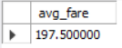

- Highest and Lowest Fare
SELECT MAX(fare_amount), MIN(fare_amount) FROM rides;
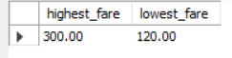

- Distance vs Fare
SELECT distance, AVG(fare_amount)
FROM rides
GROUP BY distance;
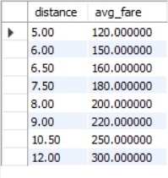
- Day-wise Analysis
SELECT DAYNAME(pickup_datetime), COUNT(*)
FROM rides
GROUP BY DAYNAME(pickup_datetime);
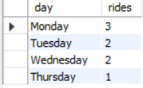

- Total Revenue
SELECT SUM(fare_amount) FROM rides;
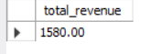

Output
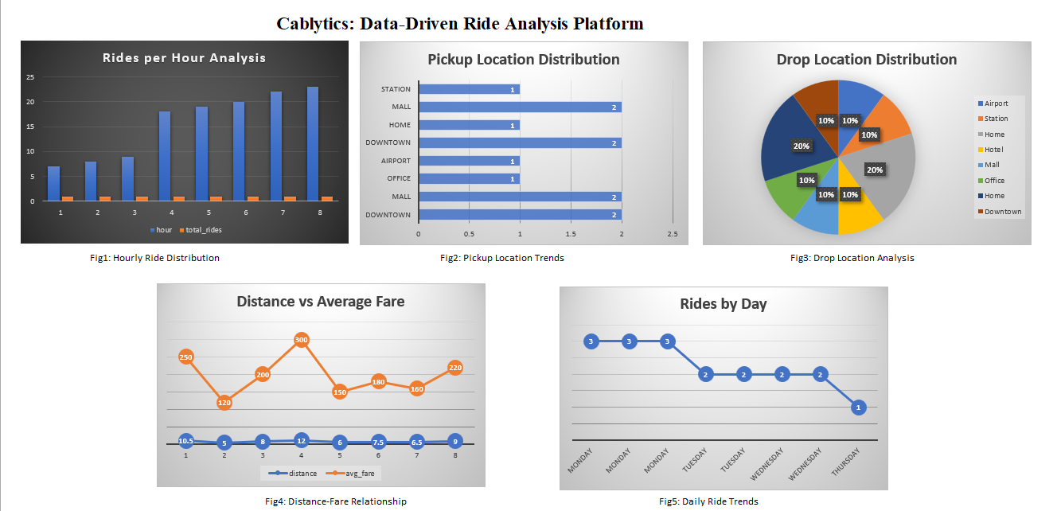

Learning Outcomes
• Learned to create databases and tables, and insert structured data using SQL.
• Gained skills in querying and analyzing data with SQL aggregation and grouping.
• Learned to visualize data in MS Excel for insights like peak hours, popular locations, and revenue trends.
• Developed analytical thinking to interpret data and support business decisions.

Conclusion
In this project, we successfully created a structured database for ride management and performed comprehensive data analysis using SQL. By executing queries for hour-wise, location-wise, and day-wise ride patterns, as well as calculating fare statistics and total revenue, we were able to extract meaningful insights from the dataset. Visualizing the results in MS Excel further enhanced understanding by highlighting trends and patterns clearly. This project not only strengthened practical skills in database creation, data insertion, and SQL querying but also developed the ability to interpret data for informed decision-making, demonstrating the importance of data analysis in optimizing business operations.

References
- MySQL Documentation – https://dev.mysql.com/doc/
- W3Schools SQL Tutorial – https://www.w3schools.com/sql/
- Microsoft Excel Support – https://support.microsoft.com/excel
- GeeksforGeeks SQL Guide – https://www.geeksforgeeks.org/sql-tutorial/
- TutorialsPoint SQL Tutorial – https://www.tutorialspoint.com/sql/index.htm

GitHub Link

https://github.com/Divyanshi2217/Cablytics-Data-Driven-Ride-Analysis-Platform

